Sri Lanka Institute of Information Technology

Year 2 Semester 1

Lab Sheet 10

**<IT24101818>**

**<DILNI J.P.B>**

**Probability and Statistics - IT2120**

B.Sc. (Hons) in Information Technology

**Question 01**

i.

ii.

**Question 02**

i.

ii.

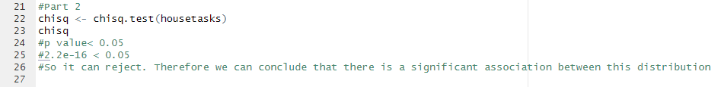

**Exercise**

